Arcade State Machine

Assignment Year One Period Two for ESE Programming C.

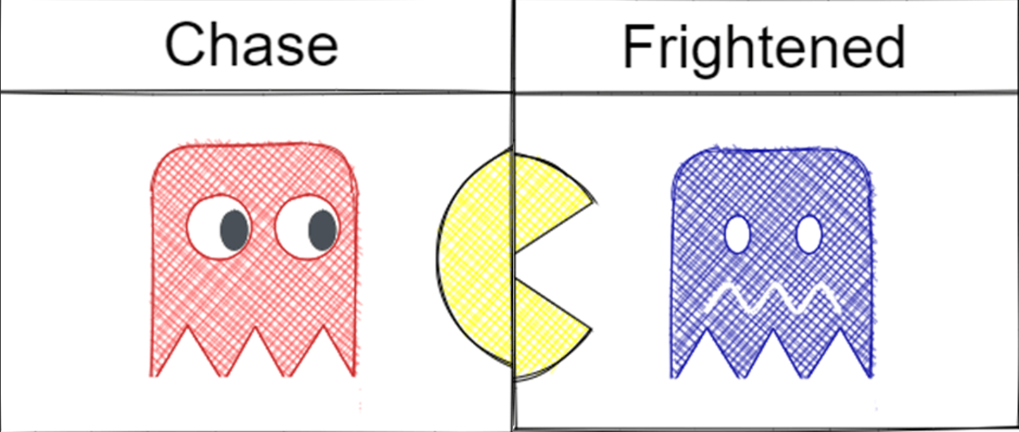
Student: Yannick Brans
Class: ESE-1C-e
Student Number: 1674806
Teacher: Peter Bijl
Date: 12/31/2023

Version log:
10-10-2023 | V0.1 | Concept
1-11-2023 | V0.2 | Adding basics like Preface and introduction
6-12-2023 | V0.3 | Adding UML/Design
24-12-2023 | V0.4 | Adding Some coding an
30-12-2023 | V1.0 | Adding all the Contents to the coding and design
1-13-2023 | V1.1 | After review finalizing things like summary and attachments.
2-25-2023 | V1.2 | Some changes regarding resit and changing the events

Summary
"The 'MultiCade' arcade machine is designed for entertainment purposes, physically constructed by the MultiCade company, and programmed for home and company use by Yannick Brans. Delivery options vary, accommodating both commercial ventures and individual users.
For businesses seeking to generate revenue, the machine is equipped with additional safety measures to mitigate legal risks. It operates on a currency exchange system where users insert euros to play selected games. In contrast, home users enjoy a more convenient and cost-free experience without the need for monetary transactions. Users also have the flexibility to choose the games installed on the machine.
The 'Arcade State Machine' project is coded in C using 'QT-Creator,' specifically tailored for arcade and company purposes. This focused approach prevents unnecessary complexity associated with accommodating diverse software needs.
To facilitate monetary transactions, the machine accepts 1 euro and 2 euro coins, with a refund option available if pressed before the game starts. The machine is preloaded with three classic retro games: Snake, Pac-Man, and Ping-Pong.
Documentation for the final product review is authored by Yannick Brans, ensuring clarity and completeness. User-friendliness is a priority, with an operator-friendly menu for easy machine operation.

Preface
In this document, you will find the report for my examination project, which is an Arcade state machine built with the C programming language. Prior to the start of this module, I had acquired some knowledge of C programming from the previous lessons. This foundational knowledge provided a good starting point for the project. While I encountered a few challenges along the way, overcoming them proved beneficial as it facilitated my learning process.
I believe that my final product has come together quite well and appears polished. I formulated a plan to execute the assignment in a structured manner, and thanks to this strategic approach, I successfully completed the project on time.

Table of Contents

1. Introduction 6
2. Definition Phase 7
2.1 Background Project 7
2.2 Functional Specification 8
2.3 Technical Specification 8
3. Design Phase 10
3.1 Layered Architecture 10
3.1.1 System Control Layer 10
3.1.2 User Interface Layer 11
3.1.3 Subsystems Layer 11
3.1.4 Hardware Abstraction Layer 11
3.2 State Machine 12
4. Realization and Testing 14
4.1 Development Environment 14
4.2 User Interface 15
4.3 Acceptance Test 15
4.4 Documentation 16
5. End Results and Recommendations 17
6. Attachments: 18

Introduction

"The 'Arcade State Machine' project is a C language-based Arcade Simulator designed for use in various settings, including homes and arcades. Whether for profit, by selling game time, or for personal enjoyment of retro games at home, these machines serve diverse purposes.
This report details the development of the C software for a state machine tailored for the Arcade State Machine project. The realized state machine emulates an Arcade machine, featuring gaming console software with a user-friendly graphical interface and integrated buttons (in this case, linked to a keyboard) for game control.
The structure of the report is as follows:
- Chapter 2 (Definition Phase): Outlines functional and technical specifications, providing insights into the machine's operation and the products used.
- Chapter 3 (Design Phase): Explores the creation of a technical solution for the Arcade machine, featuring diagrams that illustrate its construction.
- Chapter 4 (Realization Phase and Testing): Describes how the program is structured and outlines the user environment. Briefly covers the testing procedures and where detailed test results can be found.
- Chapter 5 (Final Result and Recommendations): Presents the project review, concluding with a summary and recommendations.
- Appendix: At the end of the report is the appendix, the appendix contains the Resources used for the arcade machine.

Definition Phase
The arcade machine functions as a computerized gaming console that grants users access to play various games upon the insertion of a specified amount of money. Below, I delve into a more detailed description.
2.1 Background Project
The arcade machine shown in figure 1, serves as a prominent entertainment device, primarily found in large arcades and occasionally in homes. Referred to as the 'MultiCade,' short for 'multifunctional arcade,' this gaming console aims to provide a diverse and entertaining gaming experience by offering a variety of games within a single, compact console. Users insert money into the machine for a delightful gaming experience.
The MultiCade features popular games such as Pac-Man, Snake, and Ping-Pong, adding to its appeal and ensuring a broad range of gaming options. It's a source of enjoyment for both the young and old, featuring predominantly retro games. Parents can relish the nostalgia of these classics, while kids have the opportunity to appreciate and enjoy the charm of older games.

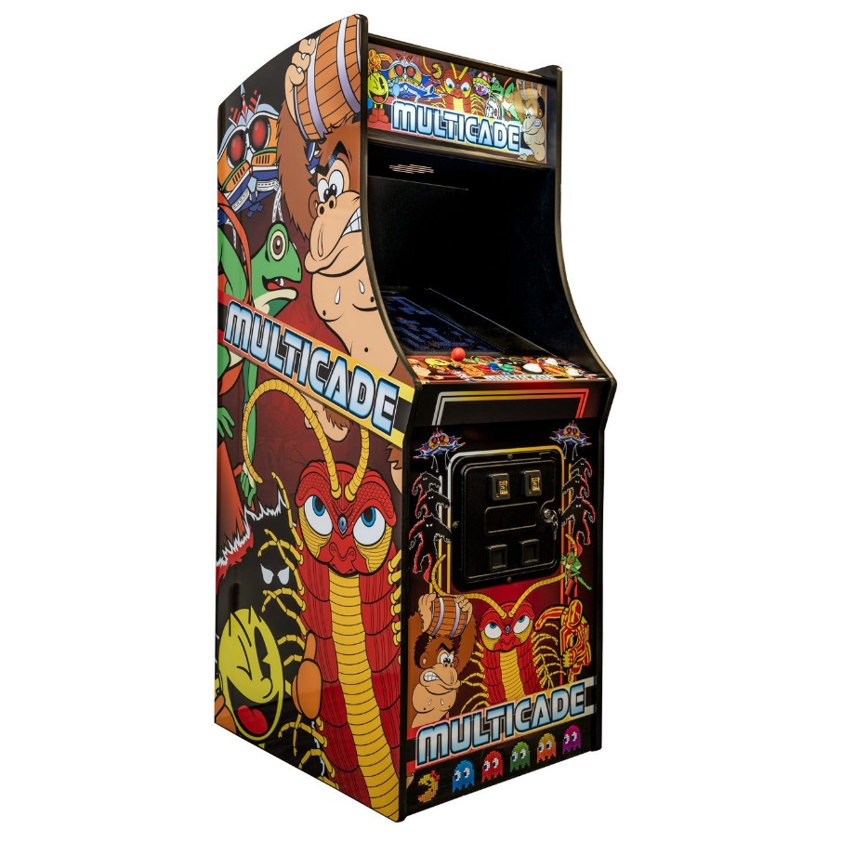
Figure 1 Multi game Arcade Machine [MultiCade]
As part of a broader initiative, the integration of these multifunctional arcade machines contributes to the creation of a dynamic gaming environment. The goal is to establish an engaging space that captures the essence of retro gaming while seamlessly incorporating modern technology. This initiative promises to offer a vibrant and immersive arcade experience for enthusiasts of all ages."

2.2 Functional Specification
These specifications cover the essential elements to ensure an enjoyable, secure, and user-friendly multifunctional arcade machine.
- Game Variety: Support for a diverse range of classic and modern arcade games.
- User Interface: Intuitive touchscreen or joystick controls.
- Payment System: Reliable coin/token slot with multi-payment method support.
- Display and Audio: High-resolution display with adjustable brightness. And a Quality audio system with volume control.
- Customization: User-adjustable game settings and accessibility options.
- Maintenance and Security: Easy maintenance access for administrators Secure cash handling and internal security to prevent stealing.
- Safety Features: Rounded edges for user safety. And Compliance with safety standards.
- Power Efficiency: Energy-efficient components. And Sleep/standby mode.

2.3 Technical Specification
The arcade machine comprises various components and is designed with diverse programs. The following programs and brands have been utilized in the construction of the arcade machine.
- Programming language: C
- Development environment: QT-Creator
- UML diagram editor: PlantUML
- Arcade brand: MultiCade
- Peripherals: Wi-Fi Router and Power supply

Figure 2 shows the user interface of the machine. User interaction is done through keyboard buttons such as:

Press 1: To choose the game Snake.
Press 2: To choose the game Pac-Man.
Press 3: To choose the game Ping-Pong.
Press 4: To reset the machine and get a refund of your money.

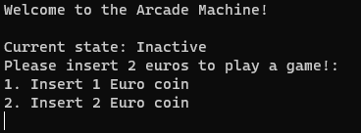
Figure 2 Screen shot of the user interface

Design Phase
This chapter elucidates the technical design, beginning with an overview of the layered architecture of the arcade machine. This depiction illustrates the hardware/software structure that underlies the programming and testing of the arcade machine.

3.1 Layered Architecture
Figure 3 shows how the system is built up in layers.
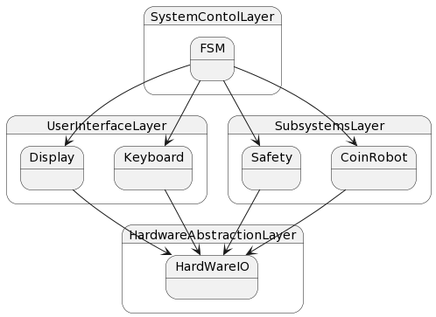
Figure 3 Layered architecture of the arcade machine

3.1.1 System Control Layer
The System Control layer plays a central role in the overall system, serving as a critical component that oversees and regulates all other layers and parts of the system. Its significance lies in its ability to exert control and coordination across the entire system architecture.
At the core of the System Control layer is the Finite State Machine (FSM), which assumes responsibility for managing both the User Interface Layer and the Subsystem Layer. Operating within a singular state at any given time, the FSM transitions between states in response to specific events, facilitating a structured and organized system behavior. Additionally, the FSM carries out the execution of various functions, contributing to the dynamic functionality of the system.
To enhance clarity and precision, it is important to specify the nature of the events triggering state transitions and elaborate on the types of functions executed by the FSM. This ensures a more comprehensive understanding of the system's control mechanism and its seamless interaction with other layers.

3.1.2 User Interface Layer
The User Interface Layer facilitates user interaction with the arcade machine and consists of a keyboard and a display. This layer serves as the primary means for users to engage with and control the arcade machine.

3.1.3 Subsystems Layer
This layer ensures the safety of the machine and verifies seamless coordination between the main code functions and the hardware, guaranteeing optimal performance and functionality.

3.1.4 Hardware Abstraction Layer
Here, the physical hardware is managed. It is controlled by the subsystems, but it can also be directly controlled through the User Interface Layer, for instance, during testing procedures.

3.2 State Machine
The state machine's design is derived from a UML diagram, specifically a UML state diagram representing the arcade machine, as illustrated in Figure 4. This diagram provides a comprehensive overview of the various states the arcade machine can assume, along with the corresponding events that trigger state transitions, such as inserting a coin to initiate a new stage.
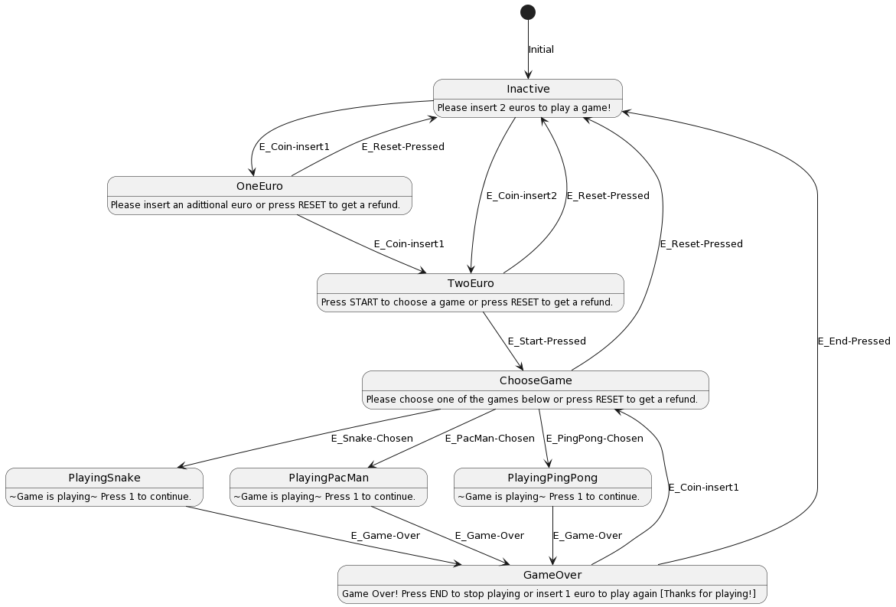
Figure 4 UML diagram Arcade machine
The initial state of the machine is designated as "Inactive." In this state, the machine awaits user input, expecting either a one-euro or a two-euro coin. Upon receiving a one-euro coin, the machine transitions into the "OneEuro" state. If a two-euro coin is inserted, the machine enters the "TwoEuro" state.
Upon entering the "OneEuro" state, the machine awaits the insertion of another one-euro coin to proceed to the "TwoEuro" state. It is in the "TwoEuro" state that the machine is ready to continue its operation.
While in the “TwoEuro” state, the machine awaits user interaction, specifically the pressing of the start button or the refund button. If the refund button is pressed, the user receives the inserted money back, and the system resets to the “Inactive” state. It's crucial to note that the refund button can also be pressed in the “OneEuro” and “TwoEuro” states to refund the money.
When the START button is pressed by the user, the machine transitions into the “ChooseGame” state. In this state, the user can select a game to play on the arcade machine. The user has four options to choose from: Snake, Pac-Man, Ping-Pong, and refund. If Snake, Pac-Man, or Ping-Pong is chosen, the machine enters the corresponding state: “PlayingSnake,” “PlayingPac-Man,” or “PlayingPing-Pong.” If the user chooses the refund option, the inserted money is returned to the user, and it's important to note that this is the last opportunity for the user to opt for a refund.
When in one of the “Playing” states (“PlayingSnake” for example), the user plays the game until they are game over. When the user is game over, the machine enters the “GameOver” state. In this state, the user can choose to insert an additional 1 euro coin to play another game. In this case, the machine returns to the “ChooseGame” state, and the user can choose another game to play. Alternatively, the user can choose to press the END button; in that case, the machine goes back to the “Inactive” state and thanks the user for playing on the machine.

Realization and Testing
The implementation details of the arcade machine can be found in the following chapters. A comprehensive test was conducted to ensure that the arcade machine meets all the specified customer requirements accurately. Every conceivable scenario has been examined, and the machine's responses to each scenario have been thoroughly evaluated.
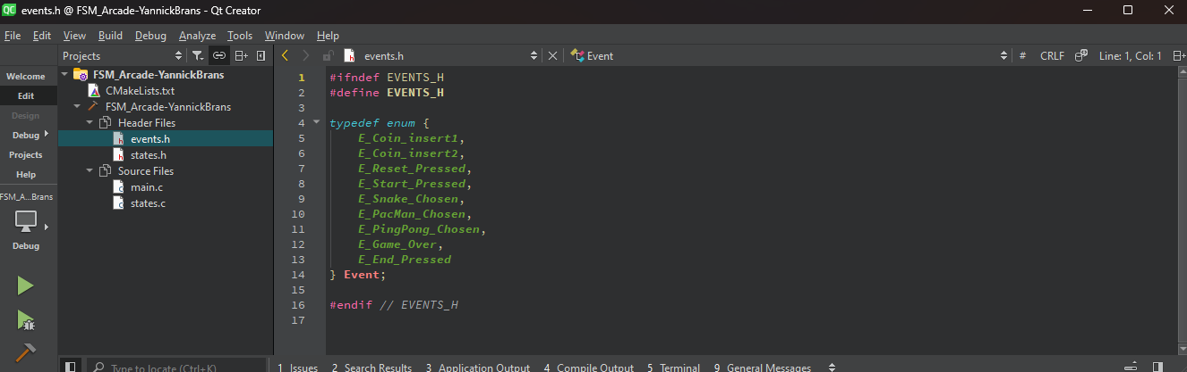
Figure 5 Development environment Qt-Creator

Development Environment
The project, titled "Arcade State Machine," was created using the QT-Creator program. In Figure 5 (above), you can observe the development environment. On the left side of the application, the "main.c" “states.c” “events.h” and “states.h” file are visible, allowing users to select and inspect the code associated with this project. Towards the bottom left of the interface, there is a green "play" button that can be pressed to execute the program for testing purposes.
On the right side of the application, you will find the development environment where the actual coding takes place. At the bottom of the interface, there is a section dedicated to issues, which is a crucial feature of QT-Creator. This section facilitates debugging, helping developers identify and address any errors in the code.

User Interface
The user interface depicted in Figure 6 comprises a segment displaying the current state of the machine. Beneath this section, user instructions are presented. These instructions may entail actions such as pressing a button, inserting a coin, or selecting a desired game to play.

Figure 6 User interface

Acceptance Test

To ensure the proper delivery of the machine to the customer, it is imperative to conduct comprehensive testing. Figure 7 illustrates a test table detailing the various tests performed.
The sequence of testing is as follows:
- Test 1: Start Application.
- Test 2: Inputs are registered and accepted.
- Test 3: Coins are accepted by the machine.
- Test 4: Player can choose and play the game.
- Test 5: Player can choose to play again after going “Game Over.”
- Test 6: Shut Down application.
Project name: Arcade State Machine |  |  |  | Date: 30.12.2023
Test case ID: 001 |  | Name: Y.J. Brans
Function/module/program under test:
ArcadeMachine
Test | Action/input |  | Expected result |  | Pass  Fail | Actual result if test has failed
1. | Application start properly |  | Displayed main menu |  | Pass
2. | Application accept user input. (On the keyboard in this case) |  | Application accepted all defined inputs |  | Pass
3. | Coins are accepted by the machine |  | The machine virtually accepted the 1 and 2 euro coins. |  | Pass
4. | Player can choose and play the game like advertised. |  | The user has the ability to select the game they wish to play. They can engage in the chosen game until they reach a "game over" state. |  | Pass
5. | Player can choose to play another game after the “Game Over.” |  | The machine prompts the user to insert another euro, and once the money is inserted, the user can play again. |  | Pass
6. | The user has the option to conclude their gaming session and shut down the system by pressing the "END" button. |  | The machine prompts the user to press "END" to conclude the gaming session, after which it initiates the shutdown process. |  | Pass
Figure 7 Test table

Documentation
This documentation is made using Microsoft word. Microsoft Word is a text processing application. It allows the user to configure the attributes of a document, such as layout and the styles of content, and to add their content in a variety of ways and formats to produce documents. Additionally, a sample product report from school has been used to gain insight into what is expected of me in the final documentation.

End Results and Recommendations
The purpose of this application is to enable users to control an arcade machine safely and intuitively. Emphasizing both safety and user-friendliness, the application has successfully met all specified requirements.
The Arcade machine requirements have been outlined as follows:
- Start Cycle: Initiates the operation of the machine.
- Waiting for 2 Euro Input: The machine remains in a waiting state until a 2 euro coin is inserted to proceed to the game selection.
- User Coin Insertion: Users can insert either 1 or 2 euro coins to cover the 2 euro cost.
- User Game Selection: The machine waits for the user to choose a game using the provided controls.
- Game State Activation: Upon user selection, the machine transitions into the game state of the chosen game.
- Post-Game Interaction: After the game concludes, the machine thanks the user and offers the option to insert an additional euro to play another game or to stop playing.
- Shutdown Cycle: Concludes the operation of the machine

Your provided text is generally well-written, but there are a few minor corrections and improvements to enhance clarity and coherence. Here's a refined version
All machine tests have been successfully passed. The user input functions smoothly, and in case of an incorrect input, the machine gracefully maintains the correct interface, preventing user confusion. The coin acceptance function operates flawlessly in the virtual space. Additionally, the games on the device are functioning as intended. The shutdown cycle is effective, ensuring proper de-initialization for a safe shutdown.
Looking ahead, if this application is implemented, it's essential to incorporate an on-screen seizure prompt for individuals susceptible to seizures, prioritizing safety.

Attachments:

- C - Source Code.
- User Manual.

